Functional Specifications
For
PO History Report

MM-PO History
MM_F1

Module | Material Management
Process | MM_F1
Sub Process / No | PO History | Process Ref
Description | PO History Report

Version
Current Version: | V1
Date Last Updated:  (dd/mm/yyyy) | 27.07.2026
Last Updated By: | Anurag Singh
Author: | Anurag Singh
Date Created:  (dd/mm/yyyy) | 27.07.2026

Revision History

Version Number | Date Updated  (dd/mm/yyyy) | Action* | Name | Summary of Major Changes Made
- 1.0 |  | - Author | - Anurag Singh | - Initial document created.
* Action Type: Author, Review, Approve
Stakeholder’s Sign-off Status

Team | Role | Signature | Date
HIGHBAR Team | Functional Consultant | Anurag Singh | 27.07.2026
 | Team Lead | NA
 | Project Manager | NA
 | Program Manager | Rajesh Shanbhag
ALIMCO Team | Core Team Lead
 | Business Process Owner
 | Project Manager | Anurag Singh | 27.07.2026

Functional Specification

Format No/ Rev: FS-ABAP-001/ 00
Version: V1  Specification No.: MM_F1  BBP Refrence: 1.  Development No MM-ALM-001 (XXX-YYY-999)  (To be filled by Technical Department) |  |  |  |  |  |  |  |  |  | Issue Date (dd/mm/yyyy): |  |  | 27.07.2026
In Preparation Review
Approved Released
Revision History
Version | Date |  |  | Description of changes
V1 | 27.07.2026 |  |  | NA
Responsible
For concept – ALIMCO |  |  |  |  |  |  |  | For Implementation – ALIMCO
Section I: Justification
Area (R/3 Module): | MM |  | Material Management |  |  |  |  |  | Date (dd/mm/yyyy): |  |  | 27.07.2026
Requested by: | ALIMCO IT team
Brief description: | PO History Report
Generic question:  1. Impact of not creating the program: |  |  |  |  | Legal requirements will not be fulfilled  Lack of information required for the business  Lose functionality compared to the old system  Others:
Is there any alternative in the standard system: |  |  |  |  |  |  | Yes No
Describe the alternative found: |  |  |  |  |  |  | NA
Reason why this alternative was not acceptable:  (Explain in brief) |  |  |  |  |  |  | Performance problems Complexity  Others:
Program type: | Report Module Pool Interface  Enhancement Conversion Form  Application Development Others
Priority: | High/mandatory Medium/recommended Low/optional
Charateristics | Drill Down ALV Others
Frequency: |  |  |  |  | Daily Weekly Monthly  Biweekly Other: As required while project creation
Only for Interfaces:  Type of interface:  Direction of interface: |  |  |  |  | Real-Time Batch  Inbound Outbound Both
Sign off – Functional Specification
Prepared By  Date |  | Jayasurya Lakkoju  27.07.2026 |  |  |  | Comments |  |  |  |  | Due to the functional consultant’s busy schedule, I have prepared the FS under Client observation.
Team Lead  Date |  |  |  |  |  | Lead Consultant  Date |  |  |  |  | Anurag Singh  27.07.2026
Approved by Project Management Team
(in case of Application development)

Section II: (a) Business Needs & Requirement (Please use this section for describing the business requirement in detail preferably with flow diagram)

Description and Purpose: This is the mandatory document, which will be use while sending the goods to customer.

- Report Selection
NA

- Report Output
NA

- Design Specification

Development Type | Customization
Module/Business Process | MM (Material Management)
Required T-Code

- Overview
- This smart form will be generated and will be used to request Invoice.

- Business Logic

- Refer to the attached files for fields required and email format for this development through a screen development for entering data with field name, length of the fields, character type, mandatory/Optional field details & list view of the fields. These should be accessible through VF02 t-code.

Enhancement Requirements:
Logic:
Exclude the ZP23 STO PO document type from the PO History radio button report.

Screenshot for reference:
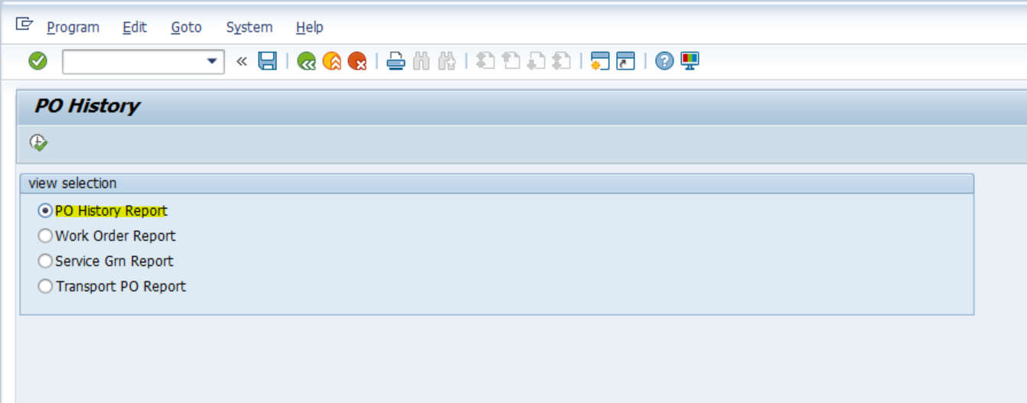
- Overview Graphic
NA

- Alternate Solutions
NA

- Selection Criteria
NA

- Output Layout
NA

- Test Plan
NA

- Related Business Scenario and Business Transactions
Business Scenario/Business Transaction-

Transaction Code (Relevant) | Description

- Target Test Date
TBC by technical team.

- Data Mapping (interface /Conversion)
NA

- Legacy files Details
NA
- Test Data
NA

- Backup / Recovery
NA

- Audit / Control
NA

